Local Community College (LCC)

Proposal

By

Anthony Grieco

Data Requirements

Database Design Documentation

Database Prototype Implementation

May 9, 2023

CS370 SP2023

Dr. Adam R. Albina

# Table of Contents

Table of Contents 2

1. Introduction and General Requirements 3

2. LCC Entity Relationship Modelling 4

Model and Narrative. 4

3. Logical Design 6

Logical Data Model and Narrative 6

4. Physical Design 8

Physical Data Model and Narrative 8

5. Prototype LLC Database 10

APPENDIX A: Sample SQL Scripts for common operations. 11

# Introduction and General Requirements

The Local Community College (LCC) contacted Anthony Grieco Consulting LLC. In order to conduct requirements analysis, design, and implementation of a database to keep details of its students, faculty, classrooms, the courses that it offers and the performance of the students who enroll in its courses. The College has only one geographic location in North America.

Information about each student is initially recorded at registration. This includes the student’s identification number issued at the time, name, planned year of graduation, majors and minors, age, gender, addressing and contact information. A student is not required to enroll in any courses at registration; enrollment in a course can happen at a later time.

Information recorded for each faculty member of the LCC must include the employee id number, name, title, office phone, office number, department, age, addressing and contact information. Each faculty member may be assigned a particular section of a course to teach or may just be doing research in that year and term. Courses are offered on a two semester basis (Fall and Spring), although LCC would like to maintain the flexibility to add summer terms and intersession terms. The Office of the Registrar will maintain the academic calendar and enter start date and end date of each year-term. A faculty member may teach more than one section of a course in a particular year and term or none at all.

Courses are taught by section. A course may have more than one section in a given year and term or it may not be offered at all during that year and term. A course that it is offered will always have at least one section. A course may be offered every term in a year or no terms in the year. A course may be offered for many years in any given term. Each course section that is offered for study must have a course identifier, a section identifier, a title, a value in terms of credit hours, identified meeting days of the week (M-W-F, T-Thu, M-W, or a single day M, T, W, Th, F), a meeting start time and a room and building designation. A course section may have a quota for the number of students allowed to be enrolled in it during a given year and term (a cap). A course section need not have any students enrolled in it. Student information for their enrollment in a course must include a record of add/drop and withdrawal dates, a midterm and final grade.

Course sections are assigned to a building and a room in the building. LCC wants to be able to specify the number of seats available in a room, which rooms contain projection equipment, audio, and a computer in order to facilitate scheduling.

LCC has issues with the quality of data that their current system provides. Clerks don't always enter the correct state abbreviation, country abbreviation, building and room information, majors and minors as well as department information. Sometimes the term is mistyped and ends up orphaning the record in a non-existent term like "Sptonf" instead of "Spring". They want to be sure that a new system mitigates the data inconsistency issues as much as possible.

# LCC Entity Relationship Modelling

Model and Narrative.

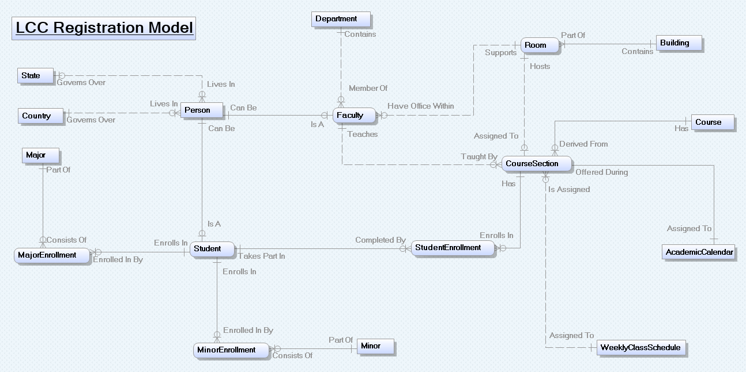

The above diagram describes the course registration system that has been employed by  
Local Community College (LCC). In short, this model tracks each person associated with LCC based on their academic progress or the courses that they teach depending on whether they are a student or faculty member. LCC offers a selection of courses every term, taught by faculty members, from which students can choose a particular course section to participate in through their enrollment for the upcoming term. Each course section is unique as it has its own assigned room (within its according building) that the given class meets in, a schedule (specifically days and start time) for when that class meets during the week, a faculty member who teaches that section, and a specific year and term as to when that particular course section is being offered based on LCC’s academic calendar. Students are able to register for zero or more classes and, similarly, faculty can teach zero or more sections of a course if they so choose for a given year and term. That said, course sections cannot exist if a course isn’t being offered, which means that neither students nor faculty can enroll in or teach it respectively for that term. However, courses can technically exist without them having any assigned sections as not all courses are offered every term. Additionally, once a course is underway, a student’s academic performance can be tracked in each of the courses that they are or have been enrolled in by LCC through their Midterm and Final grades in a particular section of a course for any given year and term. Furthermore, students tend to choose their classes for the upcoming term based on the majors and minors that they are currently enrolled in, so LCC can now specifically track all of the majors and minors that a student either currently is or has ever been enrolled in using this registration system. Accordingly, every student must be enrolled in at least one major at any given time, but they don’t necessarily need to have ever been enrolled in a minor. Similarly, faculty members have their own unique attributes as they have each been assigned to a department which corresponds to at least one major that LCC offers for its students to be enrolled in. Departments can consist of many faculty members or none at all if the major that the given department once offered to the students enrolled at LCC no longer exists. Each faculty member also has their own office on campus within a room housed by a building owned by LCC. Finally, regardless of what a person’s role actually is on campus, LLC collects both contact information, such as a person’s phone number and their email address, along with their addressing information, including their home state (if applicable) and country of origin, so that LCC can get in contact with any of the individuals that it has ever been associated with at any time.

# Logical Design

## Logical Data Model and Narrative

## Image preview

Due to how many attributes that both the “student” and “faculty” entities have in common, they have been assigned a subtype-supertype relationship with the “Person” entity being their supertype, which means that they both share the same foreign key (“PersonID”) from the “Person” entity as each of their respective primary keys. This relationship in particular abides by the Disjoint Rule because a person can only ever be either a student or faculty member exclusively at any one time. That said, both faculty members and students are always considered to be a person, but their corresponding unique attributes are what distinguish the two from one another. “PersonID” truly is the most important foreign key linking the entire model together because otherwise neither the “student” nor “faculty” entities could exist, resulting in LCC to be rendered inoperable. For example, without “PersonID” students would be unable to enroll in any classes regardless of how many courses LCC was offering because there would be no way to uniquely identify them. Similarly, there would be no way to determine which faculty member was teaching a given section of a course without “PersonID” uniquely identifying who that faculty member actually was.

Another important feature about this model is how both majors and minors can exist without anyone actually being enrolled in them. However, if someone were to enroll in either a major or a minor, they would be given only that specific academic distinction. This is possible through the respective “MajorID” and “MinorID” primary keys in the “Major” and “Minor” entities becoming foreign keys within the corresponding “MajorEnrollemnt” and “MinorEnrollment” entities. They are then linked to the “Student” entity, and therefore the “Person” entity, through the shared identifying “PersonID” foreign key between them.

There are a few other notable features of the above model. For example, each course section can only be assigned a singular meeting scheme as to when that class is supposed to meet during the week (through the “WeeklyClassScedule” entity). However, multiple sections of the same course could be assigned that same meeting schedule, or, on the other side, it is possible for certain times designated by LCC for classes to meet won’t be utilized by any course sections at all. One final thing to note is how each offered course section must logically be assigned the specific year and term in which it is being offered, but LCC’s academic calendar exists separately from the courses being offered and isn’t reliant upon classes taking place in order for it to continue to exist.

# Physical Design

## Physical Data Model and Narrative

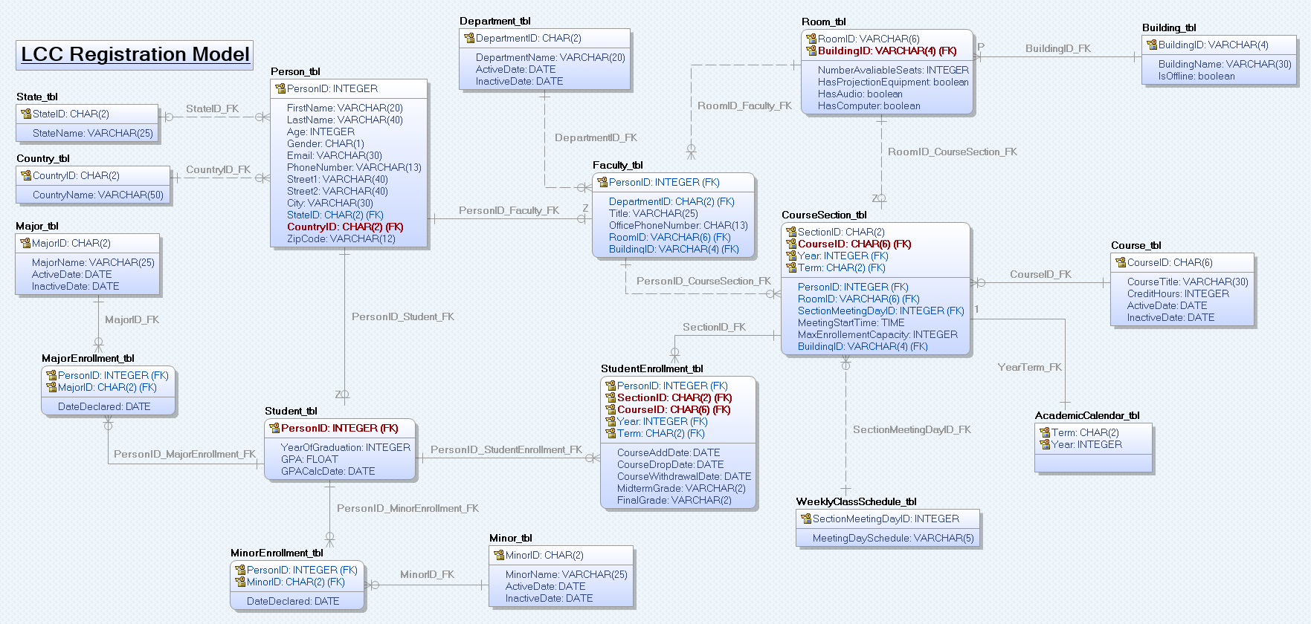

We at Anthony Grieco Consulting LLC highly recommend the use of the MySQL 8.0 RDBMS for this database project because it balances both the efficiency and thoroughness that the specifications of the above model requested by LCC requires. One specific characteristic about the above proposed model is how both the “State_tbl” and “Country_tbl” tables will be prefilled with names and codes for states and countries respectively that is consistent with US Postal Service standards in terms of addressing information both domestically and internationally for the convenience of LCC. In addition, the “PhoneNumber” field under the “Person_tbl” table has a data type of VARCHAR(13), which allows for the phone numbers collected by LCC to originate from any country in the world as it has enough space to allow for the maximum-sized international country code to be inputted along with each person’s local area code and remaining subscriber line number. This same system is also in place for the “OfficePhoneNumber” field under the “Faculty_tbl” table. Furthermore, the “RoomID” field in the “Room_tbl” and all other tables where it takes the form of a foreign key has been assigned the VARCHAR(6) data type rather than an INTEGER data type because rooms don’t necessarily need to be given a numeric identifier. For example, LCC could elect to identify one of their rooms as “Lab A” as opposed to something like “210” if they chose to do so and the proposed database would allow for it. Speaking of the “Room_tbl” table, the “HasProjectionEquipment”, “HasAudio”, and “HasComputer” fields have all been set to Booleans because they simply need to represent whether a given room has those characteristics and not how many computers or projectors that the given room contains for class registration purposes for example. Finally, the “Term” field in the “AcademicCalendar_tbl” table has been assigned a CHAR(2) data type as just one of the many error correction protocols implemented in this model in order to mitigate the issue where clerks incorrectly type in non-existent data and isolate someone’s data from the rest of the database because they accidentally created a new field for something that already exists. In this case for example, clerks would only be able to type in “SP” for the Spring term or “FA” for the Fall term. Any other entry by the clerks would violate the foreign key constraint that is inherently enforced by the database, and this same strategy has been employed throughout the entirety of the proposed database in order to avoid all anomalies in the data that would otherwise be collected by LCC.

# Prototype LLC Database

Prototype:

Schema Name: agrieco896

Hostname: anselmcs370.csjbfpcfjcgi.us-east-1.rds.amazonaws.com

Port: 3306

Username: Password:

Connection Method: Standard (TCP/IP)

# APPENDIX A: Sample SQL Scripts for common operations.